
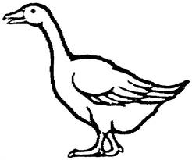
Downey- Classroom News
November 10, 2014
Treasures & Language Arts...
Theme- How animals grow
Skill- making inferences
Main Story- Farfallina and Marcel
Spelling Words- I’m don’t isn’t can’t we’ll it’s I’ve didn’t you’re that’s wasn’t you’ve us them they’re wouldn’t
Vocabulary- fluttered, giggled, peered, recognized, snuggled, vanished

Math...
Topic 6
M- adding double-digit numbers by adding the tens and the ones (not regrouping... yet)
T- using a 100 chart to add
W- adding multiples of 10
Th- finding patterns to solve problems
F- review topic 6 test (more review Monday, test next Tuesday)

Science...
We’re having a science test Thursday. I will send a study guide home Wednesday night. We will review everything at school as well. The children should know the basic plant parts and their functions, different types of animals with and without backbones, and how animals live in the habitat that is best suited for them.

Other News...
We will have seven health classes with Mrs. Hoff. We’ll start tomorrow. Children are encouraged to share their new knowledge with parents for further discussion at home.

Upcoming Events...
*Tuesday, November 11- Veteran’s Day Assembly 9:00
*Wear red, white and blue Tuesday!!!
*November 17-21- Parent Conference Week- 12:50 dismissal all week




