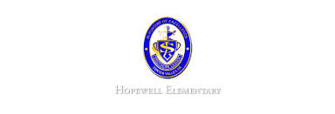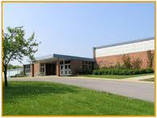

* November 11: Veteran’s Day & Report Cards sent home
* November 14-18: Parent/Teacher Conference
* November 24-28: Thanksgiving Holiday

**Ask Your Child…**

* Name a simple machine and give example.
* What is the difference between a simple machine and complex machine?
* What is a plural noun?
* Find the difference.

300-167 = _______

* Math: This week in Math the students will begin multiplication. We will learn it first as repeated addition. We will then learn how to draw arrays and use the commutative property to help us multiply. We will also learn how to write multiplication stories when we are given facts. In addition, we will review the problem solving strategy of writing to explain.
* Reading: Reading: The students will continue unit 1, week 5 of Journey’s. We will be reading the story Roberto Clemente and focusing on how to identify cause and effect in a story. We will review the signal words they may see. We will also review visualizing and how that can help us to understand a story better.
* Spelling Pattern: Long I. Our test will be Thursday, 11/10!
* Science: We will continue learning about technology and machines. We will take in depth look at the design process. We will also complete an experiment following the design process.
* Writing: The students will continue writing a personal narrative.

**Upcoming Events**

November 7, 2016

Team 19

Mrs. Pompella’s Classroom News