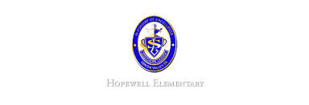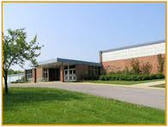

**Ask Your Child…**

* How does mass affect motion?
* Is this an example of a simple or compound sentence?

The students read the book, and the students discussed it.

* Estimate to nearest ten find the sum.

456-321

* Math: This week in math we will finish topic 2. We will learn the problem-solving strategy for the reasonableness of answers. The study guide will be sent home on Tuesday. We will review on Wednesday and Thursday. **Our test will be this Friday!**
* Reading: The students will continue unit 2, week 3 of Journey’s. We will be reading the story Destiny’s Gift and focusing identifying the story’s message. We will also learn how to analyze and evaluate the text.
* Spelling Pattern: VC_e. **Our test will be this Friday!**
* Science: We will continue our unit of study of forces and motion. We will be studying the effects of gravity. The study guide will be sent home this Thursday for our test next Tuesday, 10/18.
* Writing: The students will be learning how to write a narrative piece. We will focus of the voice-writing trait.
* October 7-10: Students Do Not Report
* October 13 5:30-7:00 PM: Open House

**Upcoming Events**

October 10, 2016

Team 19

Mrs. Pompella’s Classroom News