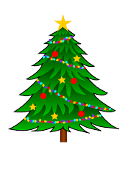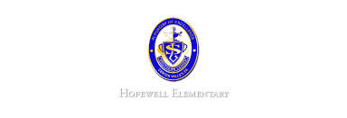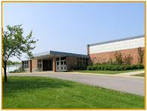

* December 22: PJ/Stuffy Day
* December 23-January 2: Winter Break

**Ask Your Child…**

* How many total directions are on a compass rose?
* How would you use the distributive property to find the product of 9 x 6?
* How can context clues help you determine the meaning of a word?
* Math: This week in math we will learn how to multiply by 8. Please continue to practice flashcards each night so your child becomes more fluent with the facts.
* Reading: The students will continue unit 2, week 2 of Journey’s. We will be reading the story The Harvest Birds and focusing on how to infer and predict. We will also review the meanings of literal and non-literal words.
* Phonics: Words with Silent Letters (kn, wr)
* Spelling Pattern: Unexpected Consonant Spellings. **Test Tuesday, 12/20!**
* Social Studies: This week in Social Studies, the students will be looking at travel brochures. We will also be talking about climate, physical geography and natural resources.
* Writing: The students will be working on an opinion-writing piece.

Wishing you all a happy and healthy holiday season!

**Upcoming Events**

December 19, 2016

Team 19

Mrs. Pompella’s Classroom News