**8.1 Functions and Domain and Range**

When you have a set of ordered pairs, it is called a ___________________.

Example: {(1,2), (2,3), (3,4)}

The set of ***x*-values** in a relation is called the _________________(input).

The set of ***y*-values** in a relation is called the _______________ (output).

A ________________ is a set of ordered pairs such that the ***x* values do not repeat**. The relation MIGHT be a function.

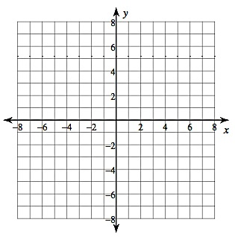Vertical line test: Graph the function. If there are more than two points that in the same vertical line, then it is NOT a function. (Two or more *y*-values that have the same *x-*value.)

Graph the relation listed above:

Is it a function? ___________

Are these functions?



Identify the domain and range of the relations below. Remember to use SET notation (braces) when identifying domain and range.

Are these relations functions? (Does the input *x*, have more than one output, *y*?)

1. {(2,4), (3,9), (-2,4), (-1,1)}

Domain: __________________ Range: _____________ Function? ____________

2. {(2,1), (3,2), (5,6), (7,2)}

Domain: __________________ Range: _____________ Function? ____________

3. {(1,4), (2,5), (1,6), (3, 4)}

Domain: __________________ Range: _____________ Function? ____________

Remember if it says graph you choose points and draw a line because ALL points are valid.

If it says graph when x = {-3, -2, 1, 3}, then you only graph those points and DON’T draw a line!

*x y*

HW: 8.1 (404) # 8 -11 (Tell if the relation is a function), 12-20 all

(You do not have to map)

**8.2 Graphing Linear Functions**

Make your own *x/y* chart. Pick your own *x*-values, then calculate the corresponding *y*-value. (Remember: I always pick *x* = 0 for one of my values.) You MUST do at least 4 points.

Graph

|  |  |
| --- | --- |
| *x* | *y* |
|  |  |
|  |  |
|  |  |
|  |  |



|  |  |
| --- | --- |
| *x* | *y* |
|  |  |
|  |  |
|  |  |
|  |  |

What if you have a fraction in front of the *x*? Pick multiples of the _______________.



|  |  |
| --- | --- |
| *x* | *y* |
|  |  |
|  |  |
|  |  |
|  |  |



You practice these:

1.



2.

How do I know these are linear functions (notice the word LINE in the word)? The *x* variable has an exponent of 1!!!!! Anytime you have a function where the exponent on the *x* variable is ONE, you have a line.

Sometimes you want to know if an ordered pair is a solution to a linear equation.

Is (2, -1) a solution? (Does this point fall on the line?)

Substitute and simplify to see if the two sides are equal.

3. Is (4, 4) a solution? 4. Is (-3, 2) a solution?

Graph the following equations:

5. 6.



HW: 8.2 (page 410) #12 – 23 *Need Graph Paper

**8.3 Intercepts**

Another way to graph lines in standard form is to find the intercepts. The *y*-intercept is where the line crosses the *y*-axis and the *x*-intercept is where the line crosses the *y*-axis.

You find the *x*-intercept by putting *_________* into the equation and solving for *______*.

You find the *y*-intercept by putting *_________* into the equation and solving for *______*.



*x*-intercept:

*y*-intercept:

Now graph using the intercepts.



HW: 8.3 (page 416) #10- 18 even, 19-20 all, 22-26 even

**8.5 Slope Intercept Form**

We have been practicing graphing lines. They have all been in the form

or we rearranged them to be in that form.

This form is called SLOPE-INTERCEPT form of a line:

The coefficient (*m*) in front of the x is called the _________________.

The constant (*b*) is called the ____________________________.

Slope is our constant rate of change. We read it from _______________________.

Slope is Rise OR Change in *y*

Run Change in *x*

Rise is how far you go up or down, run is how far right and left. If the slope is negative, you either make the rise OR the run negative – NOT BOTH!!!!!

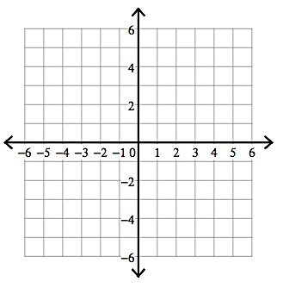Graph: and on the coordinate planes below.

As the absolute value of the slope increases, the line gets __________________.

If it goes up, the slope is ______________.

If it goes down, the slope is ____________.

The *y*-intercept (*b*) is where the graph crosses the __________________.

So if *b* is 4, it crosses the *y*-axis at 4, which is the point (____, ____).

If *b* is -3, it crosses the *y*-axis at -3, the point (____, ____).

Knowing this information helps us check to see if we really graphed our line correctly.

**

|  |  |
| --- | --- |
| *x* | *y* |
|  |  |
|  |  |
|  |  |
|  |  |

What is the slope? *m* =___________

What is the *y*-intercept? *b* = ___________

You can graph using JUST the slope and intercept, but I caution against that. I have had MANY students make mistakes. It is best to use this to check your work.

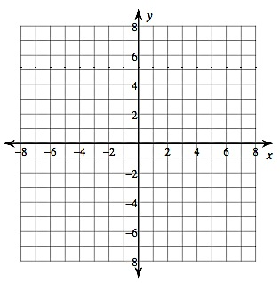

Slope (*m*): ________

*y*-intercept (*b*): _________

HW: 8.5 (page 433) #3-4, 10-12, 14-16

**8.2 Converting Equations to Function Form**

Sometimes lines are written in standard form, such as

It would be difficult to graph a line in that form. We use algebra to rearrange the standard form and put it into Slope-Intercept form.

First, remember is the slope-intercept form. We want the *y* ON THE LEFT SIDE BY ITSELF. (Solve for *y*.)

*(m* = slope, *b* = *y*-intercept)

I need to get rid of the . The is positive so I need to

SUBTRACT.

Now simplify

Almost there 🡪

Do we need to rearrange the right side?

Now you could easily graph this by choosing *x-*values and finding the corresponding *y-*values.

Rearrange into slope-intercept form. (Solve for *y.*)

1. 2.

Sometimes they are harder:

Subtract *x* from both sides.

Now divide by 2, but ***EVERYTHING*** must be divided by 2.

🡨 Look – the last term is also divided by 2!!!

*Note the becomes the fraction ½.

Rearrange into slope-intercept form. (Solve for *y*.)

3. 4.



Graph: First put the equation into

slope-intercept form. (Solve for *y*.)

5.

HW: 8.2 (page 410) #24-31 all

**8.4 The Slope of a Line**

Sometimes you are given 2 points and asked to find the slope between the points. A line is not given.



You can graph them and then find the rise and the run.

Find the slope between and .

The easier way is to use this formula:

Find the slopes between the following points. Use the formula shown above. :

1. and

2 and

3. and

*Graph #4-5 after using the formula.

4. and

5. and

HW:

8.4 (page 423) # 8 – 10, 17 – 30, 37

**8.5 Parallel and Perpendicular Lines &**

**Real World Linear Equations**

Yesterday we learned that is the slope intercept form of a line.

*m* = slope and *b* = *y*-intercept

We learned we could graph using this formula. If a line is in standard form, we switch to slope-intercept to graph it.

Now, think about parallel lines – what is true about them? _______________________

What is true about their slopes? _______________________

So if a parallel line would have what slope? _______

If , what slope would a parallel line have? __________

You try:

Find the slope of a line parallel to the line given:

1. 2. 3.

Lines that are perpendicular form _________ degree angles. Perpendicular slopes are **negative reciprocals** of each other:

If , then the slope of the line is ________.

Slope of a parallel line _______ Slope of a perpendicular line __________

If , slope is __________.

Slope of a parallel line _______ Slope of a perpendicular line __________

Find the slope of a line perpendicular to:

4. 5. 6.

Verbal model:

I have $25 saved. I can save $5 each week. If *x* is the weeks, and *y* is the total number of dollars I have saved, write an equation that represents how much money I have in *x* weeks.

How many weeks will it take me to have $55?

7. The tree is 4 feet tall. If it grows ½ a foot a year, write an equation to model this.

How many years will it take for the tree to be 7 ½ feet tall?

8.5 (page 433) #9 , 13, 20, 22 – 30

**8.6 Writing Linear Equations**

If I tell you that the slope of a line is 3 and the *y*-intercept is -3, what is the equation of the line?

*m* =_______ and *b* = _______ Therefore 🡪 *y* = ________________

1. If the slope is – ½ and the *y*-intercept is 4, what is the equation of the line?

2. If the slope of a line is parallel to but the *y*-intercept is 7, what is the equation of the line?

3. If the slope of a line is perpendicular to , but the y-intercept is -1, what is the equation of the line?

Find the equation of the line through the points (0,6) and (2, 2).

First find the slope:

You know the intercept:

What is the line?

4. Find the equation of the line though the points (0, -3) and (1, 3).

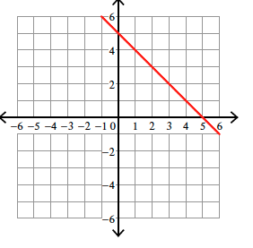Sometimes you are given a graph:

Find the intercept on the graph: _________

Find the slope on the graph: ________

Now find the equation:

5. *y* = __________________ 6. *y* = __________________

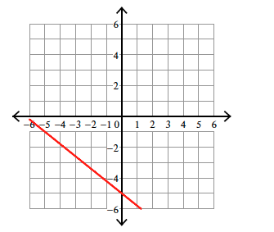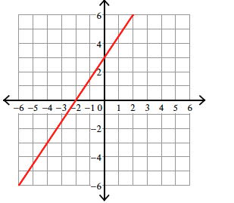

HW: 8.6 (page 442) Day 1: #8-24 even, Day 2 #9 – 25 odd

**8.6- Line of Best Fit**

Sometimes we use linear equations to approximate a data relationship on a scatter plot.

This line is called the ___________________________.

* It may pass through some of the points, all of the points, or none of the points.
* There should be the same number of points above and below the line.

Let’s graph some data points from the table below:

Is there a relationship between the fat grams and total calories in fast food?

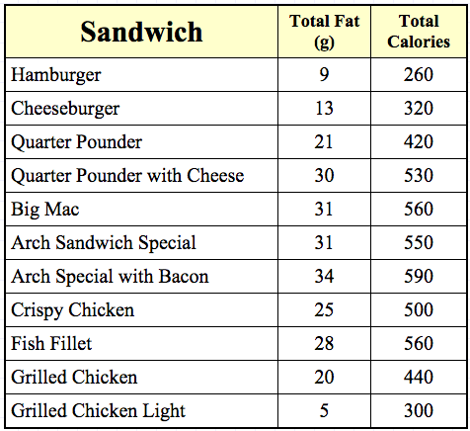

Step 1: Plot the points on the coordinate plane (on the next page.)

Step 2: Position your ruler so that the plotted points are as close to your line as possible. Remember- there should be the same number of points above and below the line. Draw your line.

Step 3: Find two points that you think will best fit your line. (_______, _______) and ( _______, _________).

Step 4: Calculate the slope of the line that passes between these two points.

Step 5: Write the equation of the line by using the slope your calculated and the *y*-intercept.

*y* = ______________________________

Predict the total calories based on 22 grams of fat: ____________

**HW: Worksheet (Next page in notes)**

**Linear Equations: Word Problems**

1. Lin is tracking the progress of her plant’s growth. Today the plant is 5 cm high. The plant grows 1.5 cm per day.

a. Write a linear model that represents the height of the plant after *x* days.

b. What will the height of the plant be after 20 days?

2. Mr. Thompson is on a diet. He currently weighs 260 pounds. He loses 4 pounds per month.

a. Write a linear model that represents Mr. Thompson’s weight after *x* months.

b. After how many months will Mr. Thompson reach his goal weight of 220 pounds?

3. Paul opens a savings account with $350. He saves $150 per month. Assume that he does not withdraw money or make any other additional deposits.

a. Write a linear model that represents the total amount of money Paul will have in his account after *x* months.

b. After how many months will Paul have $2,000 in his account?

4. The population of Bay Village is 35,000 today. Every year the population of Bay Village increases by 750 people.

a. Write a linear model that represents the population of Bay Village *x* years from today.

b. In approximately how many years will the population of Bay Village be 50,000 people?

5. Connor has $25,000 in his bank account that he has saved for college. While in college, he will spend $1,500 every month. He does not add money to the account.

a. Write a linear model that shows how much money will be in the account after *x* months.

b. How much money will Connor have in his account after 8 months?

c. How many months can Connor afford to pay his bills before he runs out of money?

6. A cell phone plan costs $30 per month plus $0.15 per text message (over the allowance.)

a. Write a linear model that represents the monthly charges of the cell phone plan if the user goes over the text message allowance by *x* text messages.

b. If you send 200 text messages over your allowance, how much would you pay?

7. A salesperson earns a base salary of $35,000 and a commission of 12% of the total sales for the year.

a. Write a linear model that shows the salesperson’s total income based on total sales of *x* dollars.

b. If the sales person sells $250,000 worth of merchandise, what is the total salary for the year?

c. The sales person would like to earn $80,000 this year. How much merchandise must she sell?

8. Kara used the linear equation to predict her total salary from achieving total sales of *x*.

a. What is her base salary?

b. What percent commission does she earn?

c. What is her annual salary if she sells $110,000 worth of merchandise?

**Domain and Range of a Function**

**Pg. 446-447**

A ____________________ function has a graph that consists of isolated points.

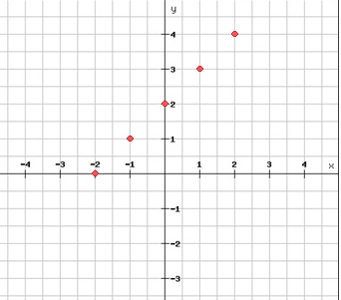

A ________________________ function has a graph that is unbroken.

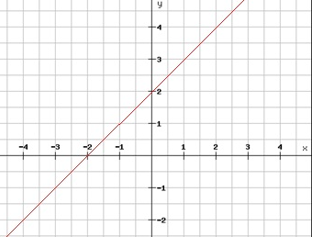

Graph the function with the given domain. Tell whether the function is discrete or continuous.

1. Domain: 2. Domain:

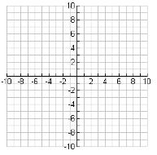

Write an equation for the function described. Tell if the function is discrete or continuous.

3. A newborn kitten weighs ¼ pound. It will grow at a rate of pound per week. How much will the kitten weigh at 20 weeks?

4. You are in charge of reserving hotel rooms for a baseball team. The rooms cost $180 plus $17 tax per night. How much will you pay if you book 10 rooms for two nights each?

HW: pg. 447 #1-7

**8.7 Function Notation**

Sometimes function are not written as .

Instead they are written as .

THESE ARE THE SAME THING!!!!

*f(x)* is read the *f* of *x*. It just means we are solving for the end thing. In this case

. I would give you some *x* value; you would put that *x* value in and calculate.

Example: let find .

You find

Now find ).

Now:

Find

Find *x* when

If , does

Does Does

The taxicab charges $1.50 to get in the cab and $0.50 per mile. Write an equation for the cab where *f(x)* is the total charge and *x* is the number of miles. (Not including tip)

How much would 10 miles cost?

How much would 25 miles cost?

How far can I go if I have $5.25?

I want to buy some shirts from an on-line store. The shipping is a flat $6.00 and the shirts are $10 a piece. Write an equation to represent the total cost *f*(*x*) of buying *x* shirts.

What would the total cost be for 6 shirts?

What would the total cost be for 12 shirts?

How many shirts could I buy for $83?

HW: 8.7 (page 451) #10 – 22 AND Challenge Word problems #1-2 (in notes)

Challenge Word Problems:

1. Kim and Cyndi are starting a business tutoring students in math. They rent an office for $400 per month and charge $40 per hour per student. Write an equation to represent the profit *f(x)* of tutoring students for *x* hours per month.

They currently have 15 students each week for one hour per week. How much profit do they make in one month? (Assume that 4 weeks is one month)

The next month, four of the current students switch to 2 hours per week. How much profit do they make in the month? (Assume that 4 weeks is one month)

2. Glen wants to rent a car for a trip to Key West for one week. The cost of a car is $63 for one week plus $0.11 per mile over 150 miles. He will be driving from Miami to Key West.

Write an equation to represent the cost *m(x)* of the rental car when driven (*x*) number of miles.

It is 167 miles from Miami to Key West. How much will Glen pay for the rental car if he drives to Key West and back to Miami? (If he doesn’t make any day trips.)

**Properties of Functions**

**Pg. 453A-453B**

Today we are going to compare functions and proportional relationships that are presented to us in different forms.

Example 1:

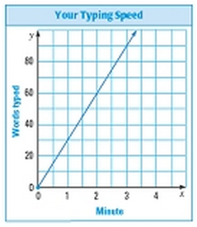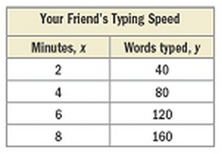The graph and table below shows the number of words (*y*) that you and your friend can type in *x* minutes. Who has the greater typing speed?

_______________________________ the greater typing speed because _____________

_______________________________________________________________________.

Example 2:

Compare the function with the linear function shown on the graph below.

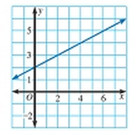

What do you notice about the slopes? ___________

__________________________________________

What do you notice about the y-intecepts? _______

_________________________________________

Example 3:

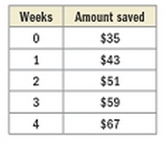You and a friend are saving up to purchase a $65 video game. You have no money saved, but plan to save $12 per week. The table below shows the money your friend plans to save.

Compare the savings plans:

Slope: ______________________________

____________________________________

y-intercept: __________________________

________________________________________________________________________

Who will be able to buy the game first? Show you work AND explain how you arrived at your answer.

________________________________________________________________________

________________________________________________________________________

________________________________________________________________________

________________________________________________________________________

________________________________________________________________________

________________________________________________________________________

HW: pg. 453 B #1-3