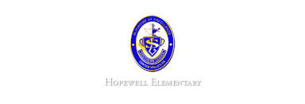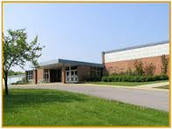

* Math: This week in math the students will begin learning about place value. We will learn how to name numbers and write numbers.
* Reading: The students will be starting lesson one. We will be reading the story A Fine, Fine School. We will focus on story structure while reading. We will also learn about using context clue.
* Spelling Pattern: VCCV pattern. No test this week.
* Science: We will continue our first topic in Science this week. In this topic, we will learn about the nature of science. This week we will investigate the kinds of questions scientists ask.
* Writing: The students will be learning how to use evidence in their writing to support*.*

**Ask Your Child…**

* Name one of the class rules and explain why it is important to follow it.
* What is one strategy that good readers use?
* Open House: Date To Be Announced

**Upcoming Events**

September 5, 2016

Team 19

Mrs. Pompella’s Classroom News