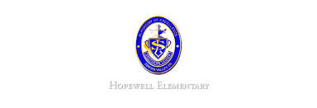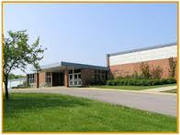

* November 24-28: Thanksgiving Holiday
* November 29: Wear Red, White and Green for ornament decorating

**Ask Your Child…**

* How can you use 6 x7=42 to find 7 x6= __?
* Using the scientific definition, how do you know if someone has done work?
* Identify the verb in this sentence.

Mary climbed the tree.

* Math: This week in Math the will take the benchmark for the first four topics in math. They do not need to study for this assessment. It will allow me to review the skills and strategies learned in the first quarter and make instruction decisions. Don’t forget, flashcards will be coming home soon. Students should practice their facts each night to build fluency. Remember to sign their agendas or they will owe 5 minutes of recess to practice their facts!
* Reading: The students will continue unit 2, week 1 of Journey’s. We will be reading the story Bat Loves the Night and focusing on how to identify and understand cause and effect using domain-specific vocabulary. We will review the signal words they may see. In addition, we will review questioning techniques.
* Phonics: Words with VCV Pattern.
* Spelling Pattern: Long & Short Vowels. **Test this Tuesday!**
* Social Studies: We will begin learning about the geography of our Earth. We will learn about what hemisphere we are located in.
* Writing: The students will be writing to a Thanksgiving prompt.

**Upcoming Events**

November 21, 2016

Team 19

Mrs. Pompella’s Classroom News