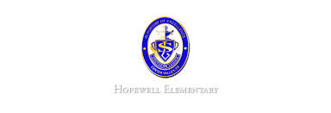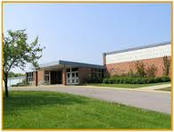

**Ask Your Child…**

* What is the difference between a main idea and a detail?
* Give an example of a common noun.
* Estimate then solve.

312-246= _______

* Math: This week in math we will continue topic 3. They will learn about how to subtract 3-digit numbers. First we will practice using place value blocks and then we will move to paper/pencil.
* Reading: The students will continue unit 1, week 4 of Journey’s. We will be reading the story Pop’s Bridge and focusing identifying the story’s structure. We will also review how to predict and make inferences.
* Spelling Pattern: Long O. Our test will be next Wednesday.
* Science: We will continue learning about technology. We will learn about simple machines. We will also use legos to construct a simple machine.
* Writing: The students will continue writing a personal narrative.
* October 25: Field Trip *must bring bagged lunch
* October 28: Halloween Parade at 2:00 PM

**Upcoming Events**

October 25, 2016

Team 19

Mrs. Pompella’s Classroom News